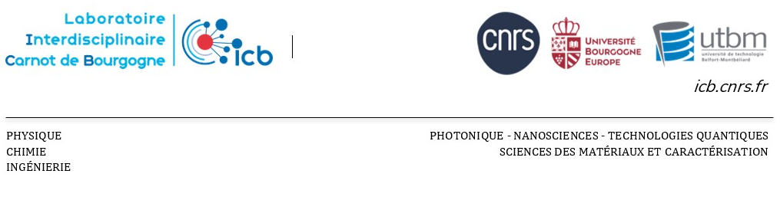

PhD Thesis Proposal

Thesis title: Low CO₂ Cement Hydration Inspired from Nature

Department / Research team: Interfaces

Thesis Supervision and, if applicable, co-supervision:
Christophe LABBEZ (Christophe.Labbez@ube.fr)
Valérie POTIN (valerie.potin@ube.fr)
E-mail:
Background – Description of the topic – Objectives (1 page max)

Carbonate biominerals form the shells of many marine organisms. These natural cements are formed through a multi-step nucleation pathway, involving the precipitation of metastable phases such as aqueous clusters or amorphous intermediates. These precursor phases interact with small fractions of organic and inorganic ions and molecules, which regulate the biomineralization process. Recent advances in the last few years have greatly contributed to the understanding of these natural crystallization processes.
In the case of engineered cements, a quest for new organic molecules controlling the hydration (hydrate particles crystallization) of alternative low-CO₂ cement formulations is ongoing. Here, we propose a cross-disciplinary project to bring concepts learned during biomineralization to inform the development of new polymers to control the setting of low-CO₂ cement formulations.
Cement production, unlike polymer-assisted biomineralization, requires a lot of thermal energy, which makes it responsible for about 10% of anthropogenic CO₂ emissions. In the long term, biomimetism is a promising route to solve this problem. In the short term, the most pragmatic solution is to develop low-CO₂ cement formulation by substituting part of the cement clinker by supplementary cementitious materials, among which calcined clays and limestones (due to their wide availability) are the best candidates.
This project aims to unravel the nanoscale mechanisms by which polymers interact with the inorganic nanoparticles formed during the nucleation and growth of cement hydrates in low-CO₂ cement formulations. The main caveat is that very little is known about how polymers control the formation, i.e. nucleation/growth, of cement hydrates, and much can be learned from the control exerted by marine organism during the biomineralization process of their shells and skeletons.

The object of this study will be the silicate-calcium system in the presence of foreign ions susceptible to being present in low-CO₂ cement formulations such as Mg²⁺ and Al³⁺. The Ca-Si-Al system can lead to the formation of the so-called C-A-S-H, a binding phase similar to C-S-H but rich in Al. A selection of organic polymers will be made from the families of polycations, anionic block copolymers, and amphoteric polymers.
We plan to provide answers by using a combination of state-of-the-art scattering, imaging and spectroscopy techniques combined with kinetics and thermodynamic modeling:
- Chemical evolution of aqueous (pre-nucleation) clusters in low-CO₂ cements will be studied with potentiometric titrations of calcium and silicate solutions.
- The formed solids will be characterized by lab-based techniques including ICP-OES, TGA, FTIR, Raman, AFM, DSC (sensor to be ordered via this project) and SEM.
- TEM experiments will be performed to characterize the shape and chemical composition of the precursor phases. In-situ TEM experiments will be carried out using a specific sample holder allowing to image samples in a self-contained and fully hydrated flowing and mixing chamber.
- In situ synchrotron-based X-ray techniques (PDF and SAXS) will be used to characterize the early stages of formation of low-CO₂ cement hydrates.

Keywords: Nucleation; cement; hydration; low CO₂; polymer; biomineral; decarbonization

Candidate profile:
The candidate for this project should have a master degree in the field of inorganic chemistry, materials science or solid-state chemistry. A strong background in these disciplines will be crucial for conducting this research and achieving the objectives of the project. Experience in chemical analysis is required, as the candidate will need to chemically characterize materials using different techniques, including ICP, TGA, FTIR, DSC. To characterize these materials, the student will also need to use experimental techniques such as X-ray techniques and electron diffraction. Experience in thermodynamic and/or kinetic modeling is a plus.
Excellent communication skills in English and/or French, both spoken and written (writing skills).

¹Cement clinker is produced from a mixture of clay (~20%) and CaCO₃ (~80%) burned at high temperature (~1500°C); ~60% of CO₂ emissions come from the decarbonation of CaCO₃

